Maitland Valley Marina - FOR SALE
Lot – D13  1992 Brenkenridge 838FRB  Move in condition to enjoy!  - Fully paid 2020 Lot Fees  - 2 bedrooms:  - 1-double bed with lift for storage  - 3 bunks  - Sofa bed, queen  - Walk through 4-piece bathroom  - New carpet in sitting area  - Fully Furnished  - Air Conditioning  - Deck – 30- x 8’ (2017)  - Shed  - Bar-be-que  - Propane/electric water heater  - Propane furnace  Asking - $14,500 |  | 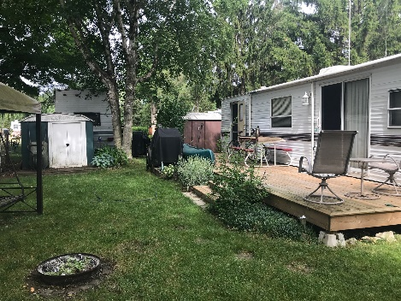
 |  | 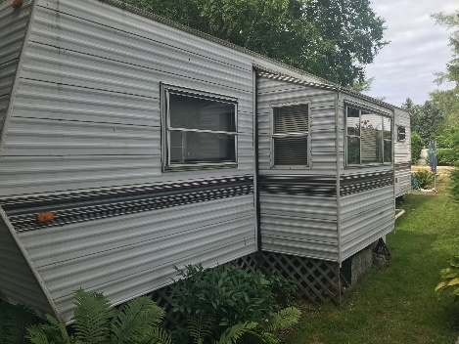
 |  | 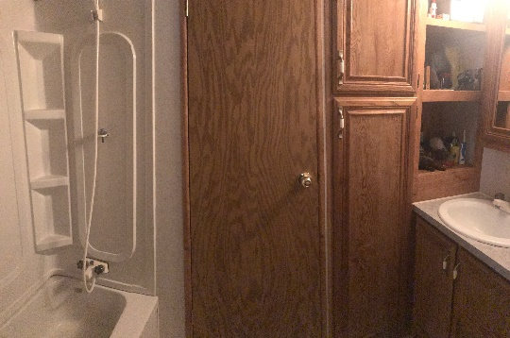
 |  | 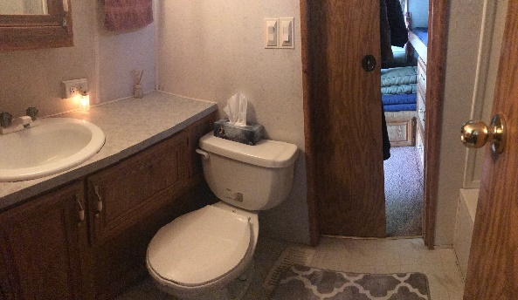
 |  | 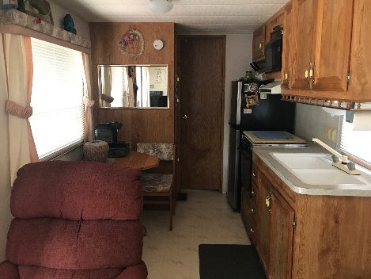
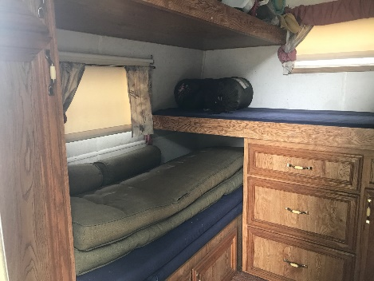 | 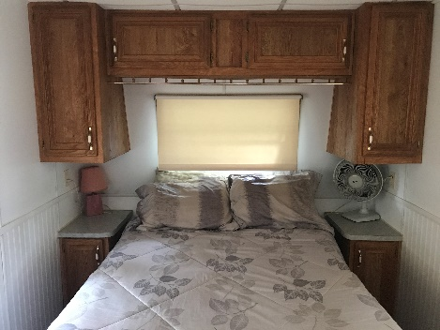 | 