Maitland Valley Marina - FOR SALE
Lot – B12  2013 Jayco Jay Flight  35’ BHDS  - 2 bedrooms – 1 queen bed & 1 double bed  - Sofa bed  - Sleeps 8  - Full refrigerator with Ice Maker  - 8’ x 20’ deck with hard awning  - 6’ x 8’ shed  - Propane Stove  - Propane and Electric water heater  - Propane Furnace  - Air Conditioning  - TV & Stereo with DVD Player  Trailer in excellent condition!  Internet & Cable TV available  Asking - $32,900 |  | 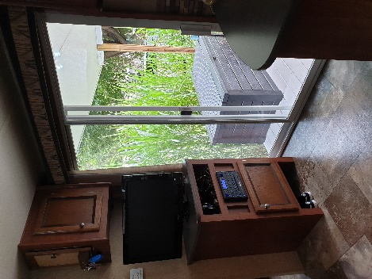
 |  | 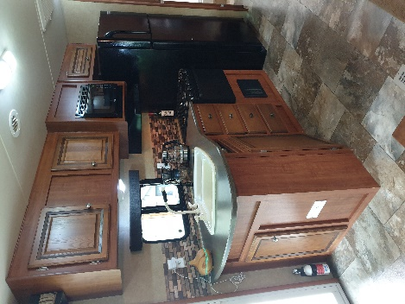
 |  | 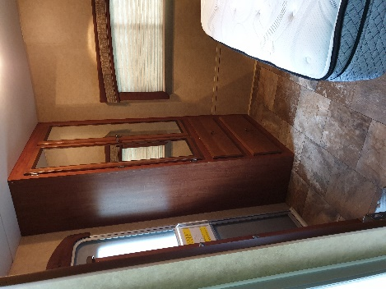
 |  | 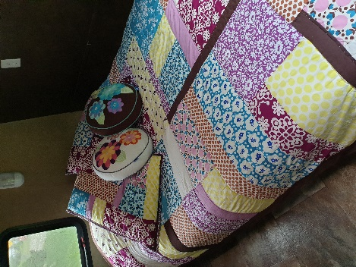
 |  | 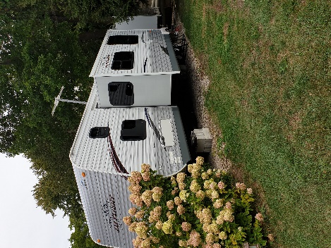
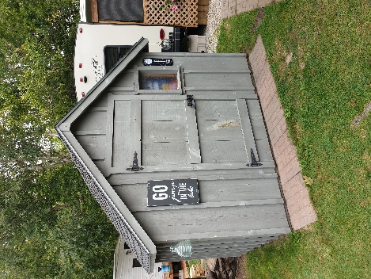 | 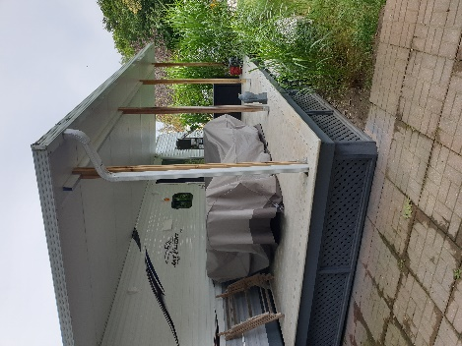 | 