Maitland Valley Marina - FOR SALE
Lot - C12  1996 Travelaire Park Ave.  - 35’ with 2 tip-outs, 3 season trailer in excellent condition  - Wonderful location and view of water overlooking the marina  - 3 burner stove with over (propane), full size fridge and double sink  - Partial wood floor and large deck  - 3 piece bathroom, tub/shower, sink and toilet  - Bedroom has new mattress and good storage  - Trailer has propane heat, central air and storm windows  - New rubber roof in 2015  - Sliding Door from living room to deck  - Shed  - Also included are dining room table and four chairs, two deck tables, two umbrellas and 8 chairs  Asking - $19 500 | 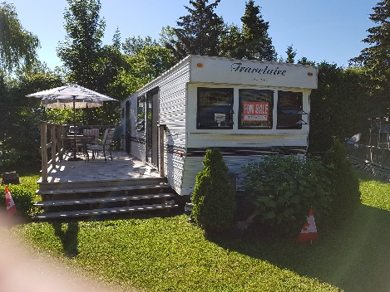
 | 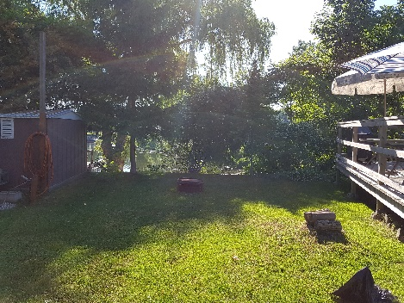
 | 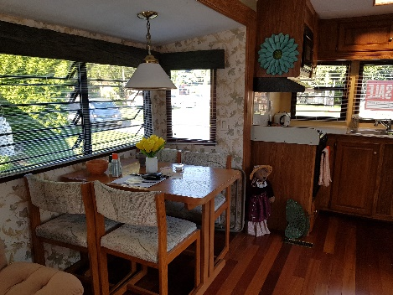
 | 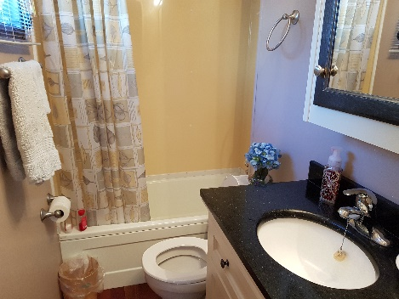
 | 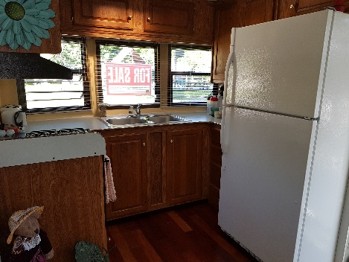
 | 